Draft order

Current balance = 22.99

New Draft Order (ORD-2122-000224)

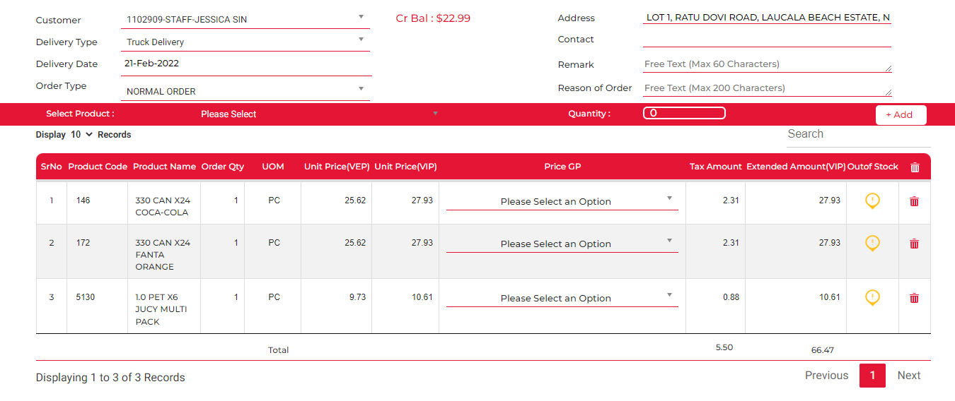



View order:

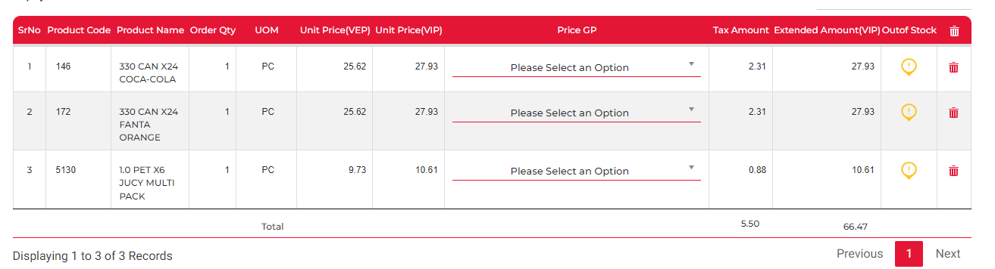

Add New item:

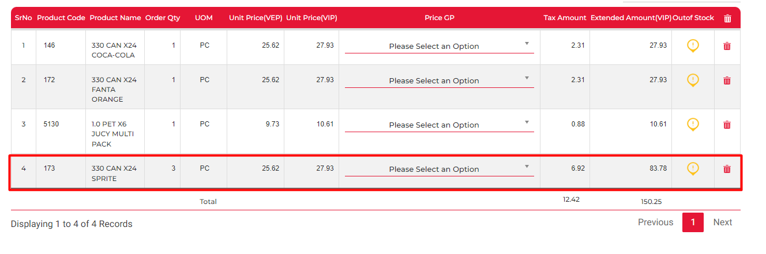



(The Order details is not updating in the Draft order screen)

View Order:

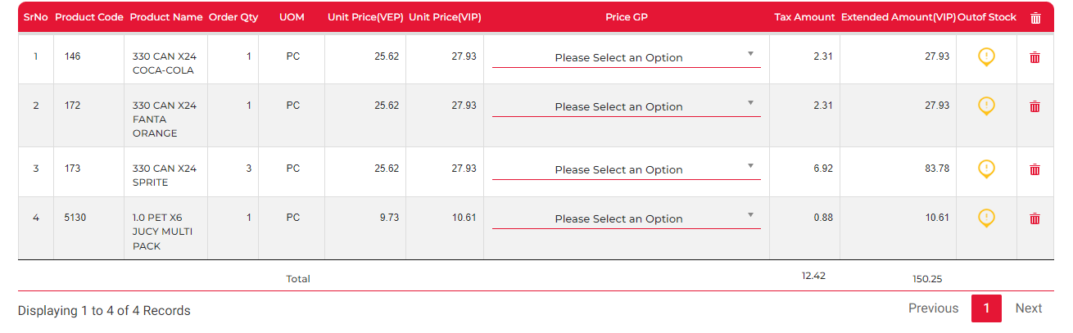

Update Qty:

5130 qty 1 -> qty 2

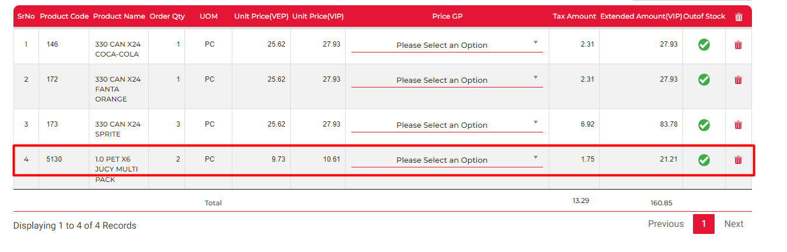



View Order:

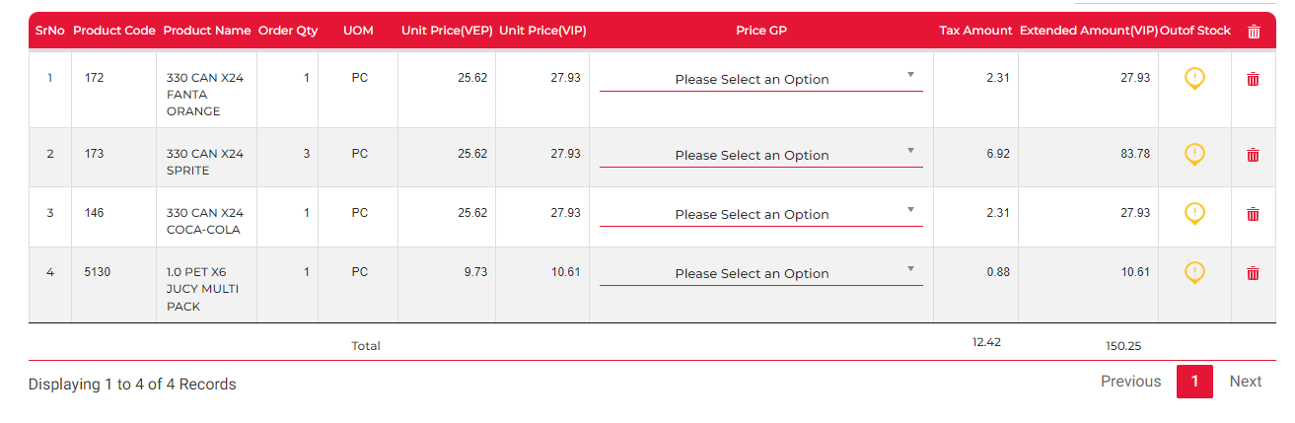

(Not updating)

Remove item:

Removed line 5130



View Order:

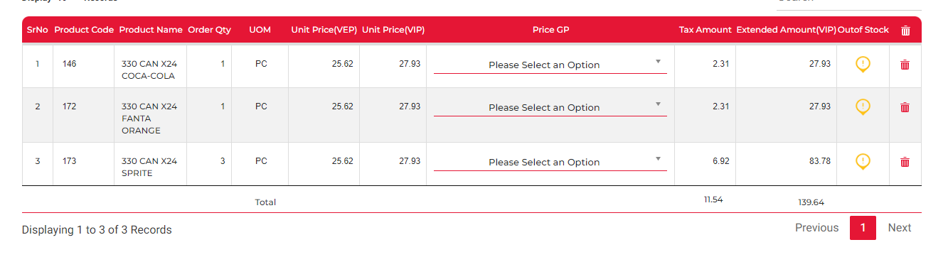

Adding item 5130 qty1 and then removing the rest of the items. This will be < balance

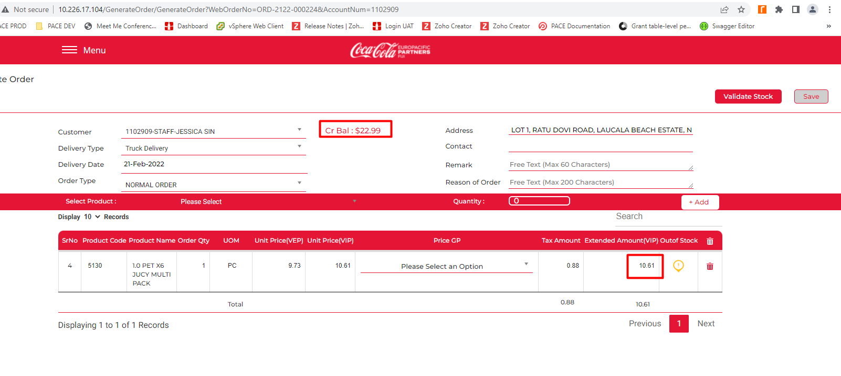

All good

